Lab Report for Module 1 Dropbox

Lab: What’s Going on in There?

Submitted by: Tristan Izlar

1. This is the start view of the monitoring utility for windows (task manager).

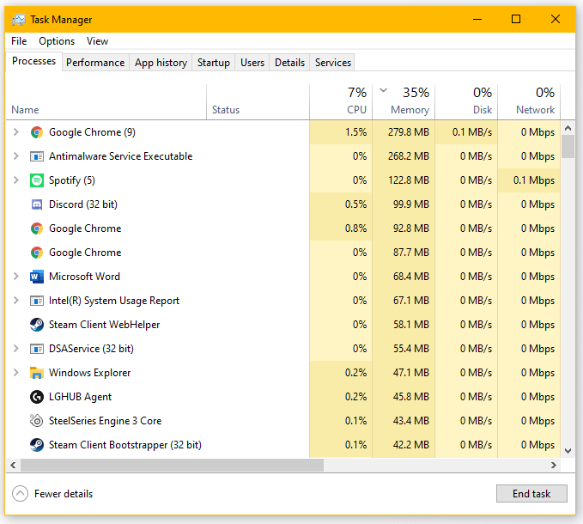

1. While taking this snip, my CPU utilization was at 8%.

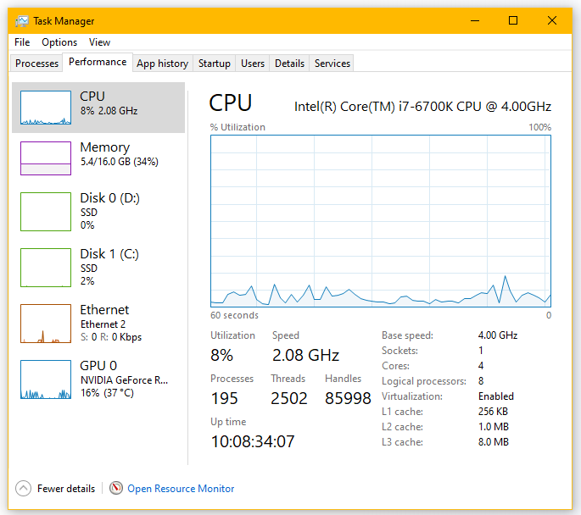

1. Currently snipping tool has the highest CPU utilization, at 0.6%

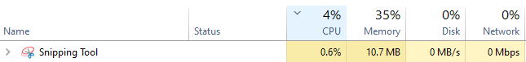

1. GCloud (32 bit) was a process unknown to me. It is a part of the CloudStation program developed by GIGABYTE. I confirmed it is not malware.

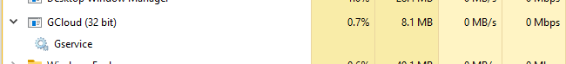

* 1. Currently the System process is at 0.1 MB.



* 1. The process using the most memory is Google Chrome at 274.7 MB.

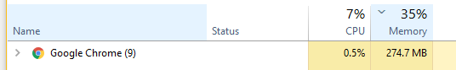

1. Spotify was writing data at the time of this screenshot. Spotify is a music streaming application.

